Pie Chart

Definition
# Source: AI Source: Provided by: [Data Path: Persons Table -> ID Column: 1, Name_En Column: Motasem Essam] -> From: [Chatgpt (GPT‑5 Mini)] on [12/10/2025]
A Pie Chart is a circular data visualization that shows proportions or percentages of a whole. Each slice of the pie represents a category’s contribution to the total.

Key Idea
# Source: AI Source: Provided by: [Data Path: Persons Table -> ID Column: 1, Name_En Column: Motasem Essam] -> From: [Chatgpt (GPT‑5 Mini)] on [12/10/2025]
Pie charts are used to visualize parts of a whole, making it easy to see which categories are largest or smallest in proportion.

How It Works
# Source: AI Source: Provided by: [Data Path: Persons Table -> ID Column: 1, Name_En Column: Motasem Essam] -> From: [Chatgpt (GPT‑5 Mini)] on [12/10/2025]
- Identify the categories and their corresponding values.
- Calculate the percentage of the total for each category.
- Draw a circle divided into slices proportional to the percentages.
- Optionally, use colors or labels for each slice to enhance clarity.

Example
# Source: AI Source: Provided by: [Data Path: Persons Table -> ID Column: 1, Name_En Column: Motasem Essam] -> From: [Chatgpt (GPT‑5 Mini)] on [12/10/2025]
Dataset: Market Share of Products
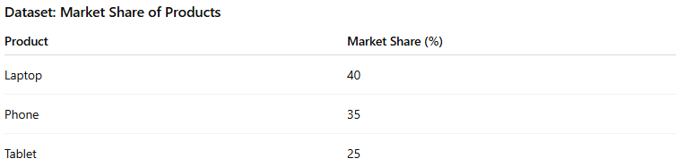
Product | Market Share (%)
Laptop | 40
Phone | 35
Tablet | 25
- Each slice represents a product’s percentage of total market share.
- Laptop slice = 40% of the circle, Phone = 35%, Tablet = 25%.
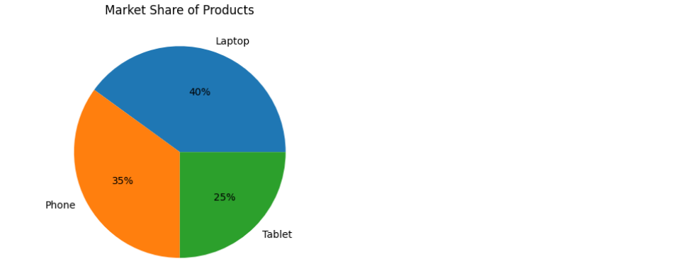

Applications
# Source: AI Source: Provided by: [Data Path: Persons Table -> ID Column: 1, Name_En Column: Motasem Essam] -> From: [Chatgpt (GPT‑5 Mini)] on [12/10/2025]
- Showing composition of a total
- Visualizing market share, budget allocation, or survey results
- Presenting proportions to audiences

Advantages
# Source: AI Source: Provided by: [Data Path: Persons Table -> ID Column: 1, Name_En Column: Motasem Essam] -> From: [Chatgpt (GPT‑5 Mini)] on [12/10/2025]
- Simple and easy to understand
- Highlights largest and smallest categories
- Good for presentation and communication

Disadvantages
# Source: AI Source: Provided by: [Data Path: Persons Table -> ID Column: 1, Name_En Column: Motasem Essam] -> From: [Chatgpt (GPT‑5 Mini)] on [12/10/2025]
- Not suitable for many categories (can become cluttered)
- Difficult to compare slices accurately
- Only represents proportions, not exact values

